***Adı: Matematik Tarih***

***Soyadı: Kazanım Değerlendirme ....../....../2017***

***1--------------------Mini Test--------------------***

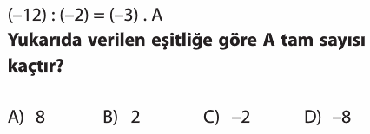

***2-----------------------------------------------------------***

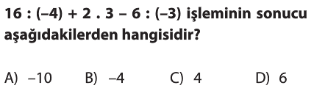

***3-----------------------------------------------------------***

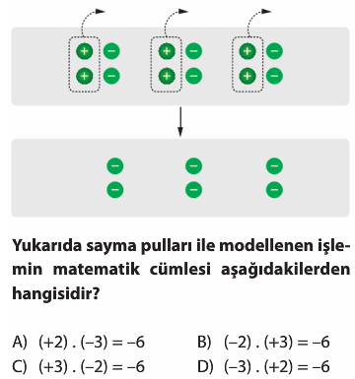

***4-----------------------------------------------------------***

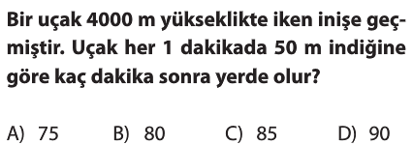

***5-----------------------------------------------------------***

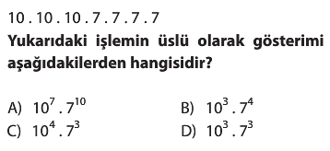

***6-----------------------------------------------------------***

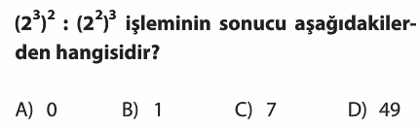

***7-----------------------------------------------------------***

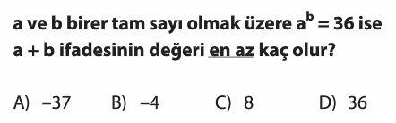

***8-----------------------------------------------------------***

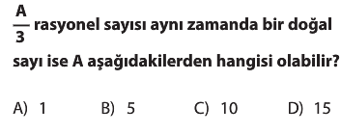

***9---------------------------------------------------------***

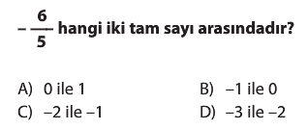

***10---------------------------------------------------------***

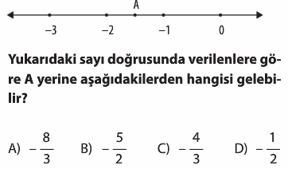

***11---------------------------------------------------------***

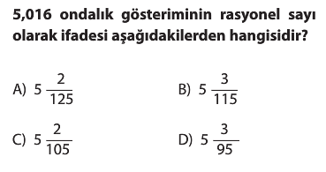

***Adı: MATEMATİK***

***Soyadı: Konu Tekrar Testi***

***16---------------------------------------------***

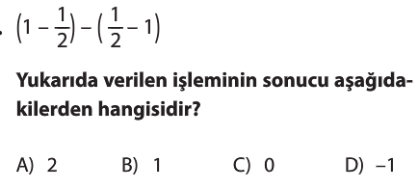

***17---------------------------------------------***

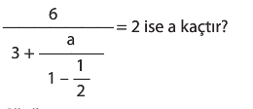

***18---------------------------------------------***

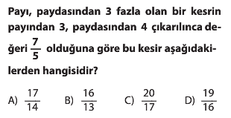

***19---------------------------------------------***

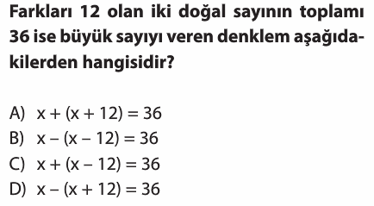

***20---------------------------------------------***

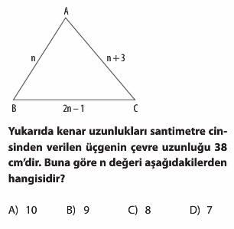

***Türkçe Öğretmeni***

***Aytuna SERT***

***12--------------------------------------------------***

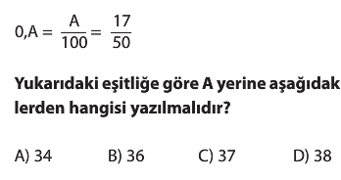

***13--------------------------------------------------***

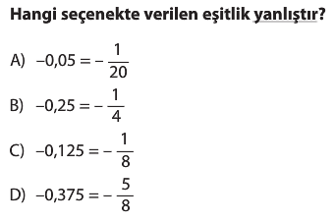

***14--------------------------------------------------***

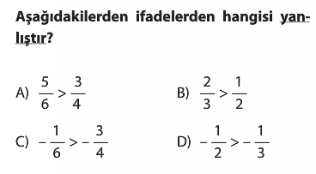

***15--------------------------------------------------***

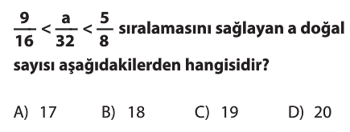

***16--------------------------------------------------***

