***Adı: Türkçe Tarih***

***Soyadı: Kazanım Değerlendirme ....../....../2017***

***1--------------------Mini Test--------------------***

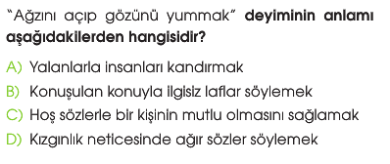

***2-----------------------------------------------------------***

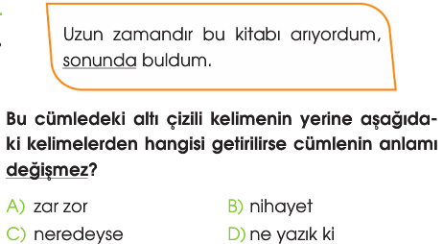

***3-----------------------------------------------------------***

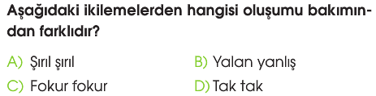

***4-----------------------------------------------------------***

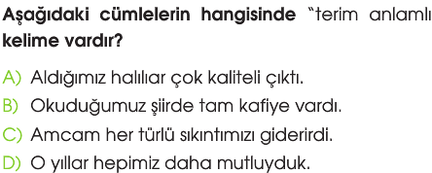

***5-----------------------------------------------------------***

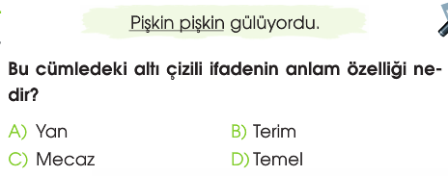

***6-----------------------------------------------------------***

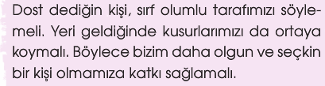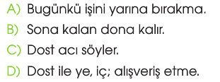

***7-----------------------------------------------------------***

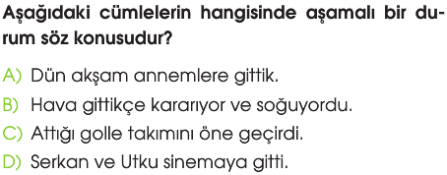

***8-----------------------------------------------------------***

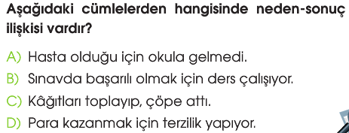

***9-----------------------------------------------------------***

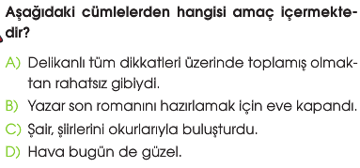

***10---------------------------------------------------------***

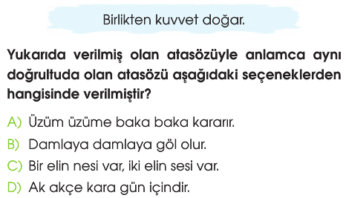

***11---------------------------------------------------------***

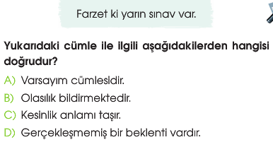



**Zeka Sorusu (BENZER ÖZELLİK)**

*4--10 a) 22---42*

*11--31 b)25--73*

*9--25 c)31--93*



***Adı: MATEMATİK***

***Soyadı: Çalışma kağıdı***

***15-----------------------------------------***

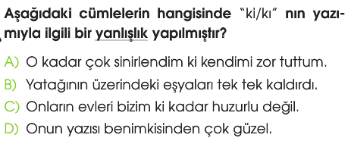

***16--------------------------------------------------------***

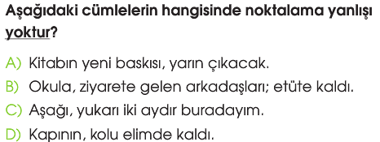

***17--------------------------------------------------------***

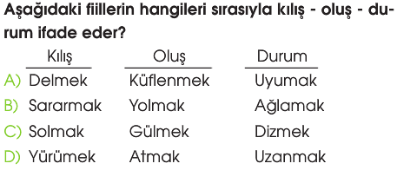

***18--------------------------------------------------------***

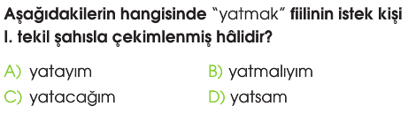

***19--------------------------------------------------------***

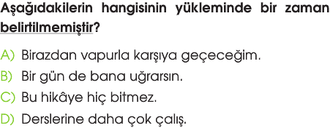

***20--------------------------------------------------------***

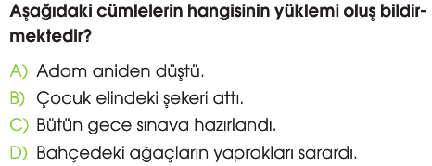

***21--------------------------------------------------------***

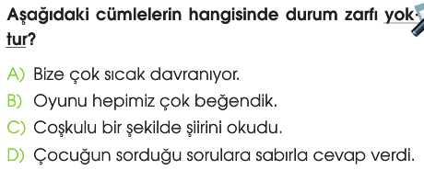

***Türkçe Öğretmeni***

***Aytuna SERT***

***12-------------------------------------------------------***

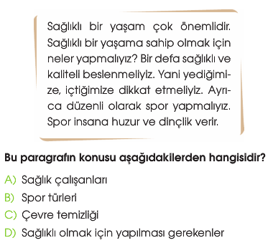

***13-------------------------------------------------------***

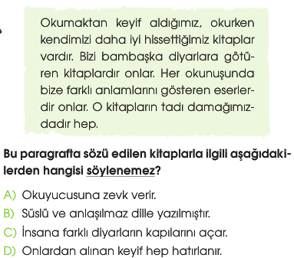

***14-------------------------------------------------------***

