***Adı: Türkçe Tarih***

***Soyadı: Kazanım Değerlendirme ....../....../2017***

***1--------------------Mini Test--------------------***

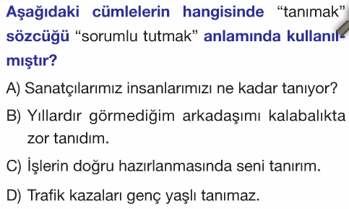

***2-----------------------------------------------------------***

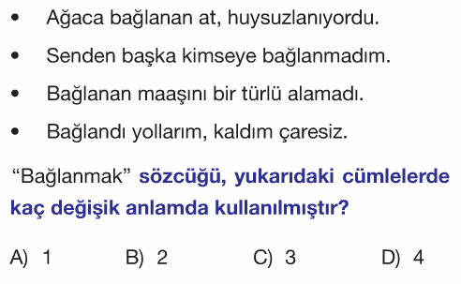

***3-----------------------------------------------------------***

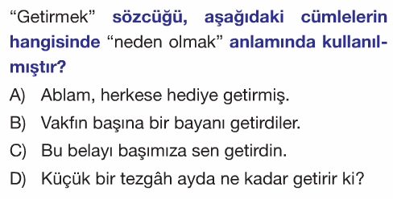

***4-----------------------------------------------------------***

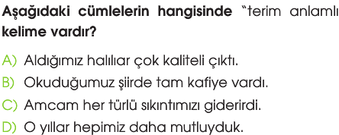

***5-----------------------------------------------------------***

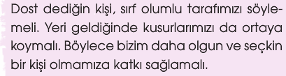

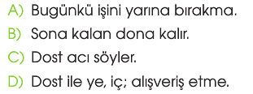***---------------------------------***

***6-----------------------------------------------------------***

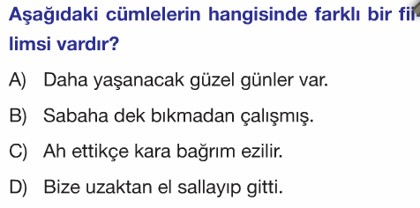

***7-----------------------------------------------------------***

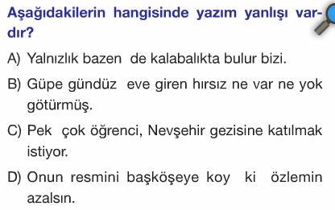

***8-----------------------------------------------------------***

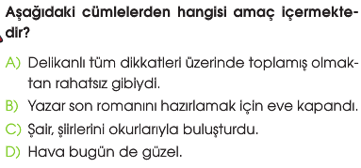

***9---------------------------------------------------------***

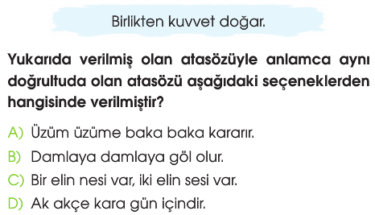

***10---------------------------------------------------------***

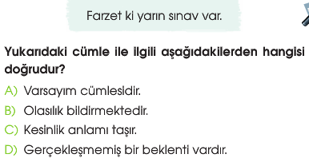

***Adı: TÜRKÇE***

***Soyadı: Çalışma kağıdı***

***16-----------------------------------------***

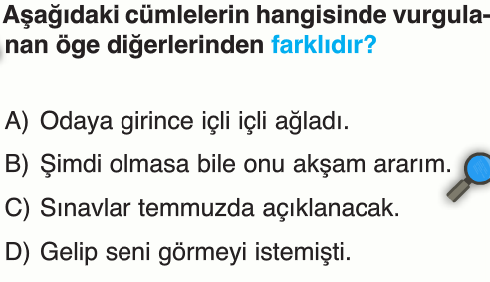

***17--------------------------------------------------------***

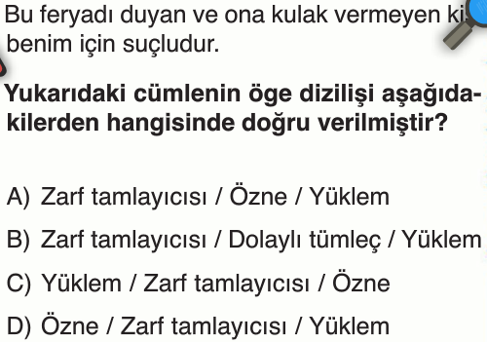

***18--------------------------------------------------------***

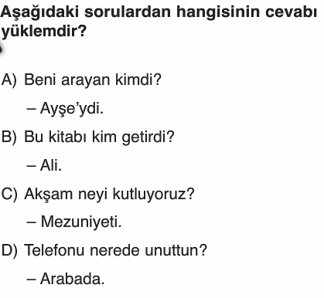

***19--------------------------------------------------------***

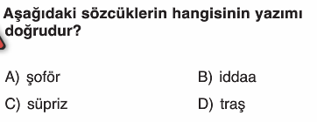

***20--------------------------------------------------------***

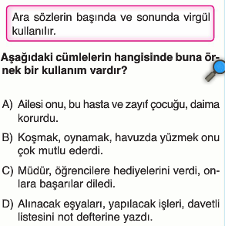

***12-------------------------------------------------------***

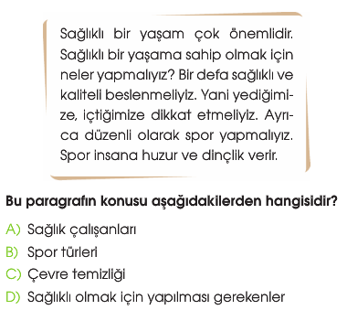

***13-------------------------------------------------------***

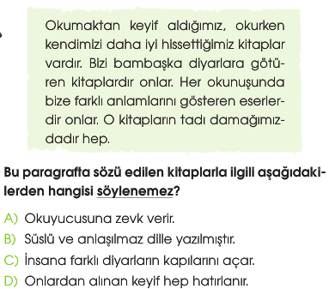

***14-------------------------------------------------------***

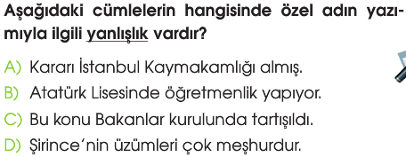

***15-------------------------------------------------------***

