



***Adı: TÜRKÇE Tarih***

***Soyadı: Tema Değerlendirme ....../....../2018***

***7-------------------------------------***

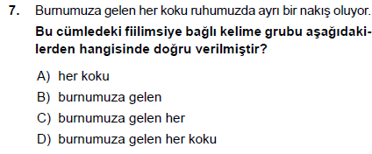

***8----------------------------------***

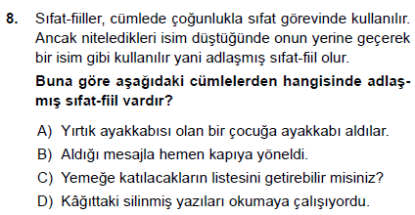

***9----------------------------------***

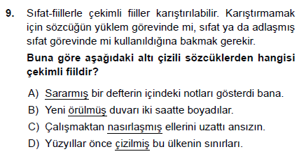

***14----------------------------------***

***---------------------------***

***4----------------------------------------***

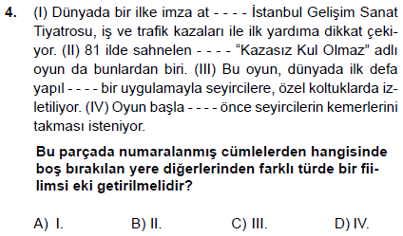

***5----------------------------------------***

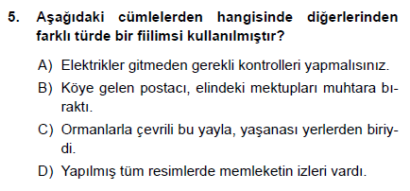

***6----------------------------------------***

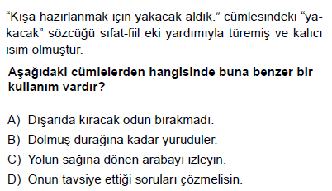

***9-------------------------------------***

***10-------------------------------------***

***1------------------------------------------***

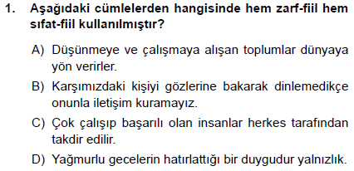

***2------------------------------------------***

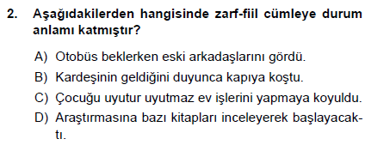

***3------------------------------------------***

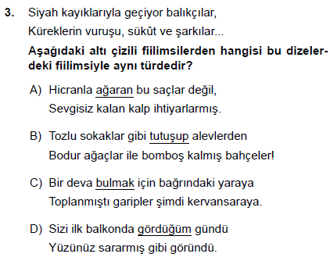

***4------------------------------------------***

***5----------------------------------------------***

***6----------------------------------------------***

***7----------------------------------------------***

***8----------------------------------------------***

***9------------------------------------------***

***18-------------------------------------***

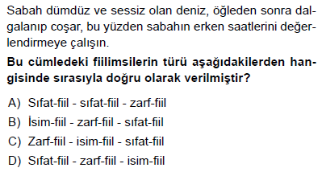

***19-------------------------------------***

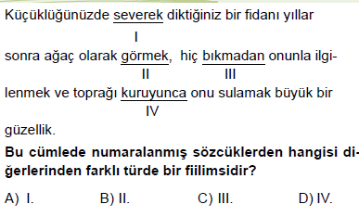

***20------------------------------------***

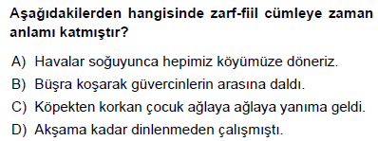

***21-------------------------------------***

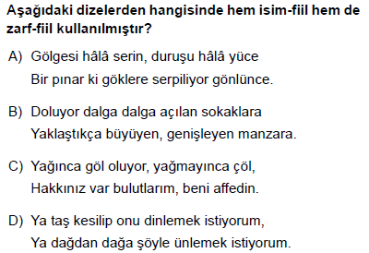

***8/A Sınıfı Çalışmaları***

***Enes SERT***

***10------------------------------------------***

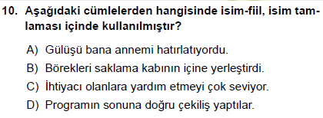

***11------------------------------------------***

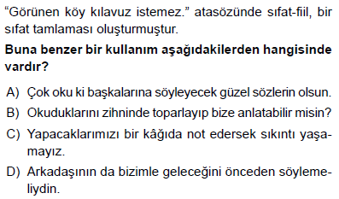

***12------------------------------------------***

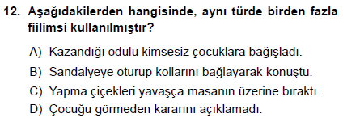

***13------------------------------------------***

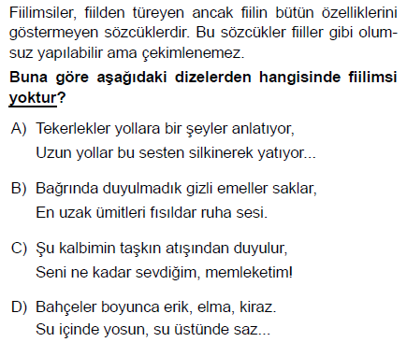

***14----------------------------------------***

***15----------------------------------------***

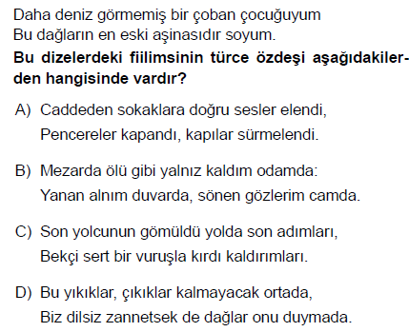

***16----------------------------------------***

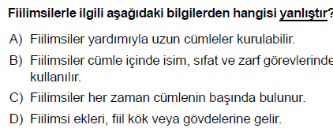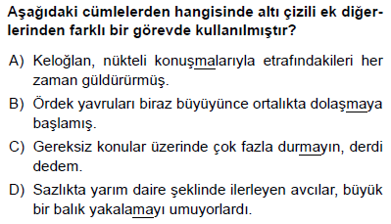

***17----------------------------------------***

***5----------------------------------------***

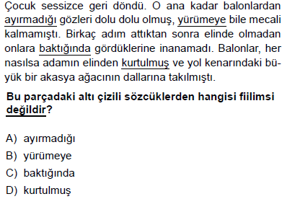

***6------------------------------------------***