ccccccc





***Adı: FEN BİLİMLERİ Tarih***

***Soyadı: Çalışma Kağıdı ....../....../2018***

***7------------------------------------***

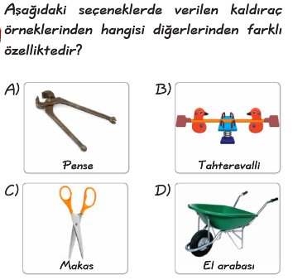

***8------------------------------------***

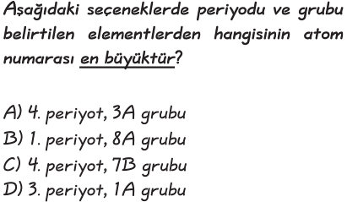

***9------------------------------------***

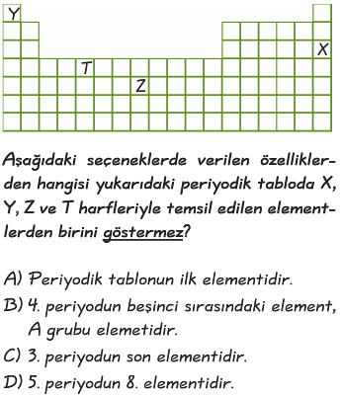

***10----------------------------------***

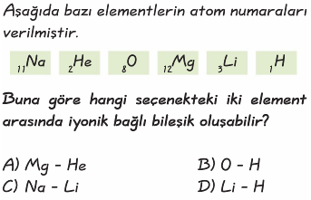

***4------------------------------------------***

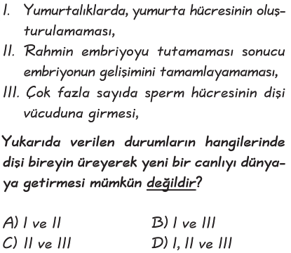

***5-----------------------------------------***

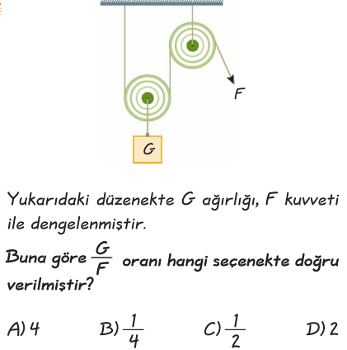

***6------------------------------------------***



***1------------------------------------------***

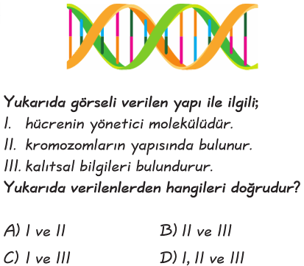

***2------------------------------------------***

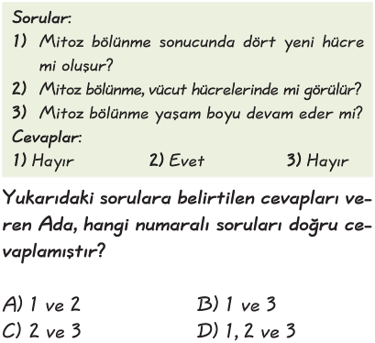

***3------------------------------------------***

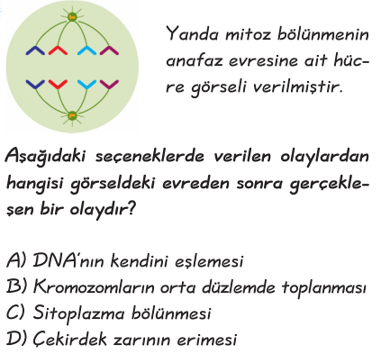

***7------------------------------------***

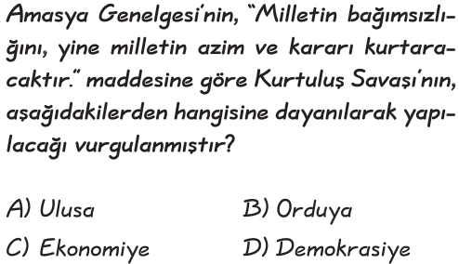

***8------------------------------------***

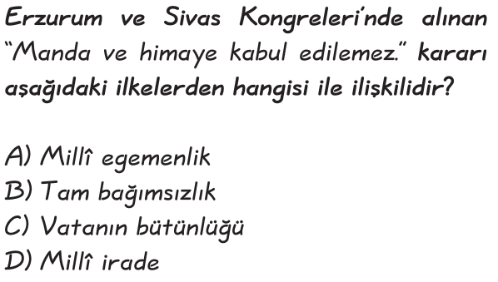

***9------------------------------------***

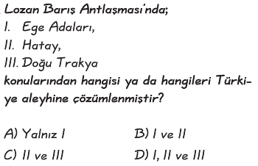

***10----------------------------------***

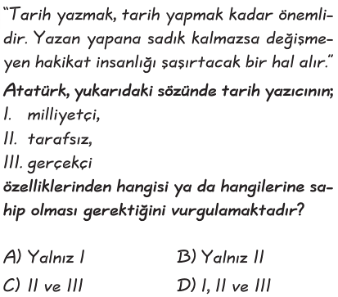

***İNKILAP TARİHİ***

***1--------------------------------------------***

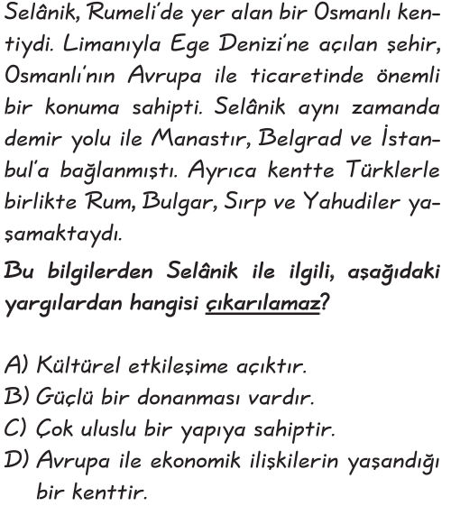

***2--------------------------------------------***

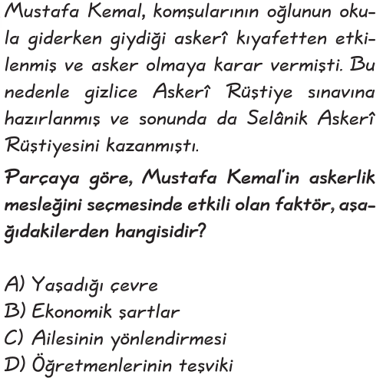

***3--------------------------------------------***

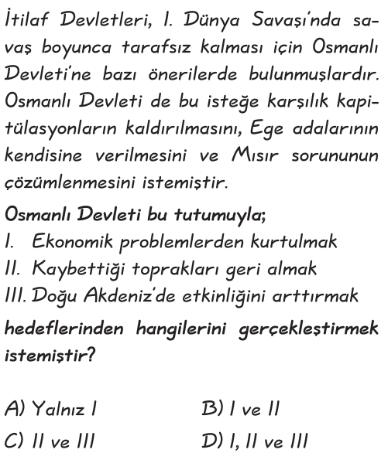

***4------------------------------------------***

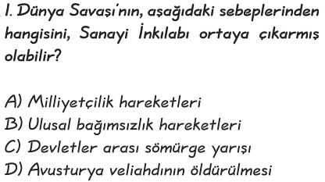

***5------------------------------------------***

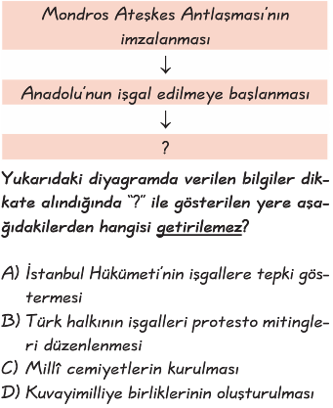

***6------------------------------------------***

