



***Adı: MATEMATİK Tarih***

***Soyadı: TEKRAR ....../....../2018***

***1------------------------------------------------------------***

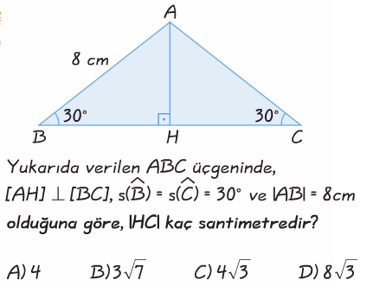

***2-----------------------------------------------------------***

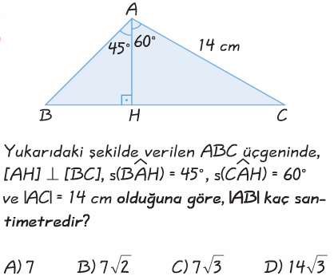

***3------------------------------------------------------------***

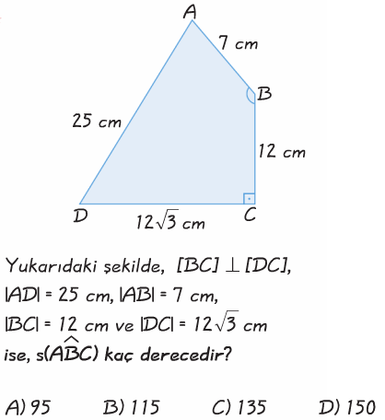

***4------------------------------------------------------------***

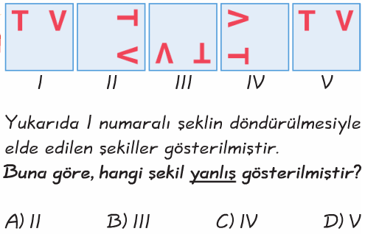

***5-------------------------------------------------------***

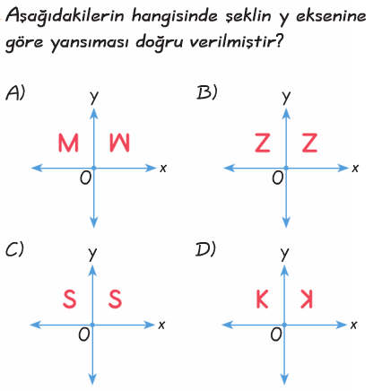

***6--------------------------------------------------------***

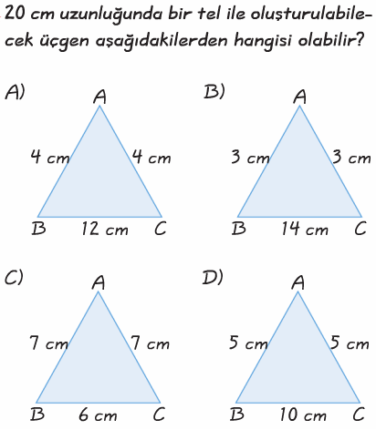

***7--------------------------------------------------------***

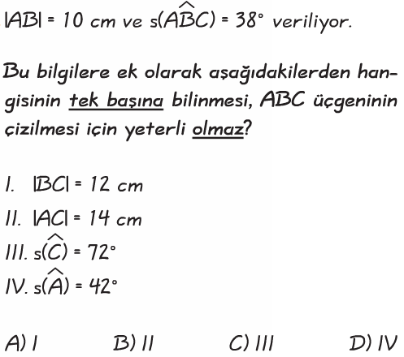

***ENES SERT***

***8/A SINIFI ÇALIŞMALARI***

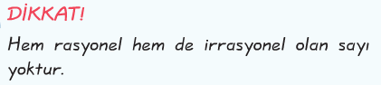





***Adı: MATEMATİK***

***Soyadı: GENEL TEKRAR***

***14------------------------------------------------***

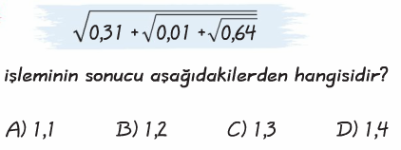

***15------------------------------------------------***

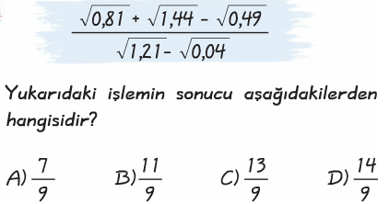

***16-----------------------------------------------------------------***

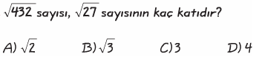

***17-----------------------------------------------------------------***

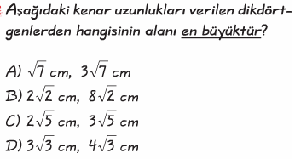

***18----------------------------------------------------------------***

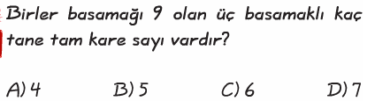

***19----------------------------------------------------------------***

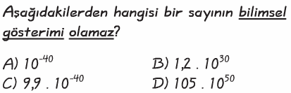

***20----------------------------------------------------------------***

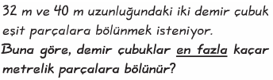

***8-----------------------------------------------------***

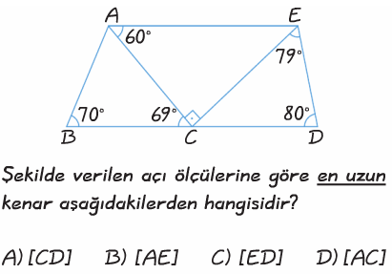

***9-----------------------------------------------------***

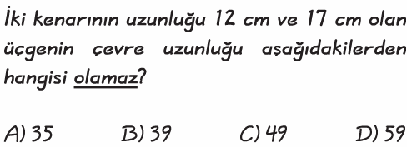

***10----------------------------------------------------***

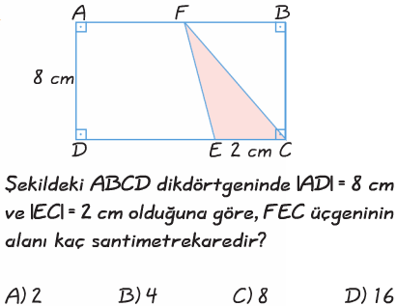

***11----------------------------------------------------***

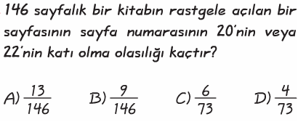

***12-----------------------------------------------------***

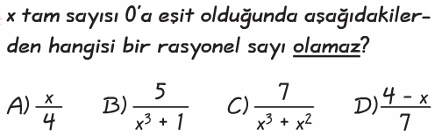

***13----------------------------------------------------***

