



***Adı: MATEMATİK Tarih***

***Soyadı: Çalışma Kağıdı ....../....../2018***

***8---------------------------------------***

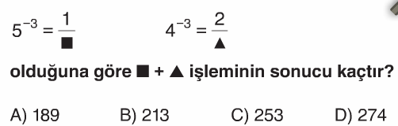

***9------------------------------------***

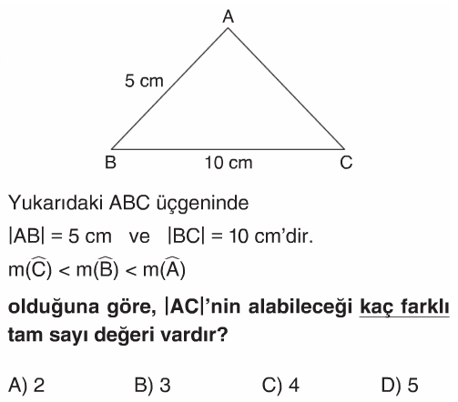

***10----------------------------------***

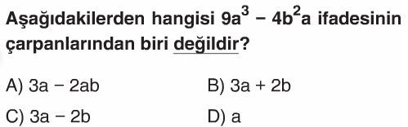

***11----------------------------------***

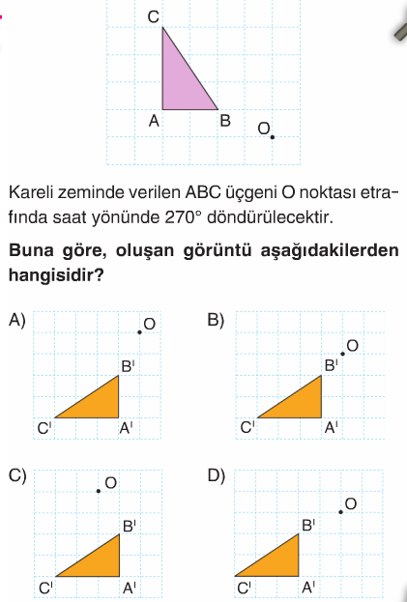

***5------------------------------------------***

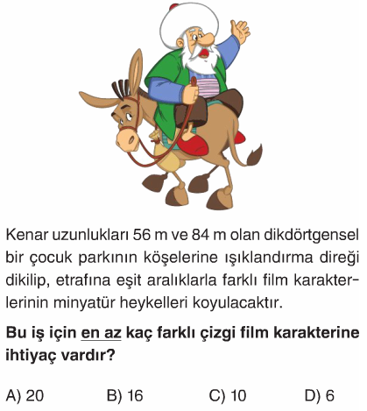

***6------------------------------------------***

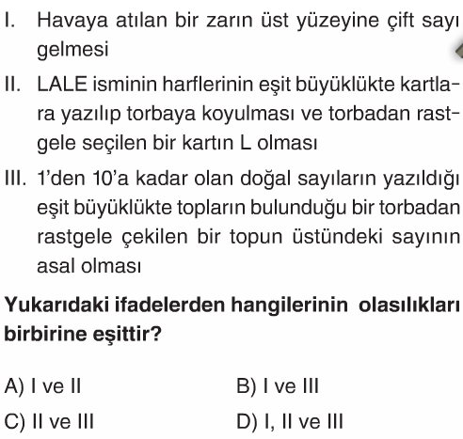

***7------------------------------------------***

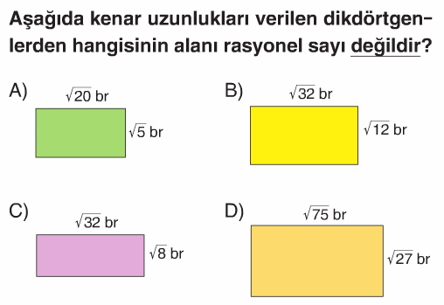

***MATEMATİK***

***1------------------------------------------***

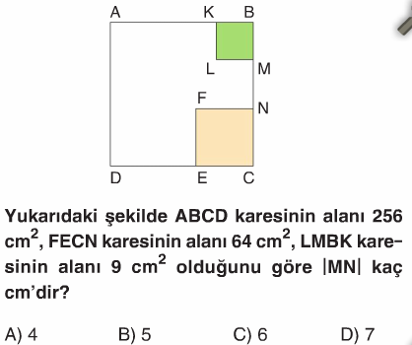

***2------------------------------------------***

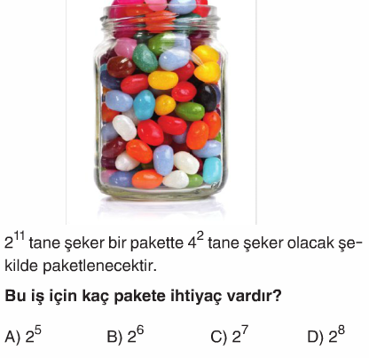

***3------------------------------------------***

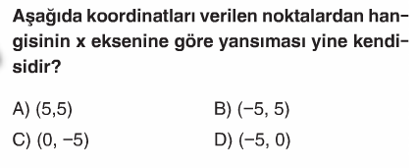

***4------------------------------------------***

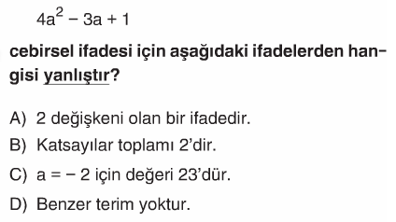

***19-------------------------------------***

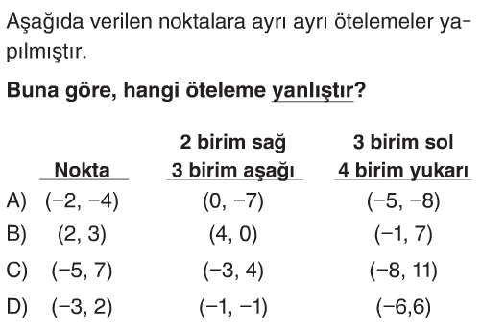

***20-------------------------------------***

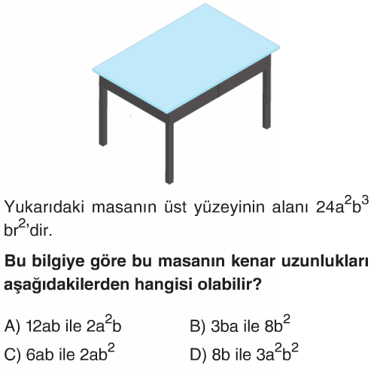

***ENES SERT***

***8/A SINIFI MATEMATİK SORULARI***

***12------------------------------------------***

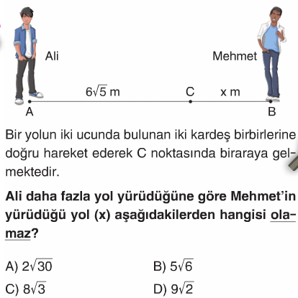

***13------------------------------------------***

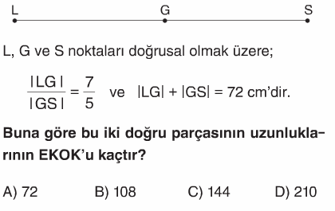

***14------------------------------------------***

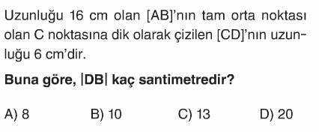

***15------------------------------------------***

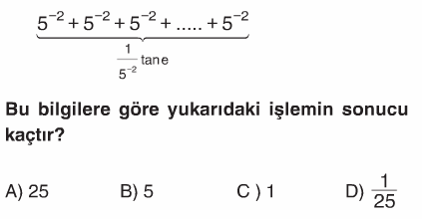

***16---------------------------------------***

***17----------------------------------------***

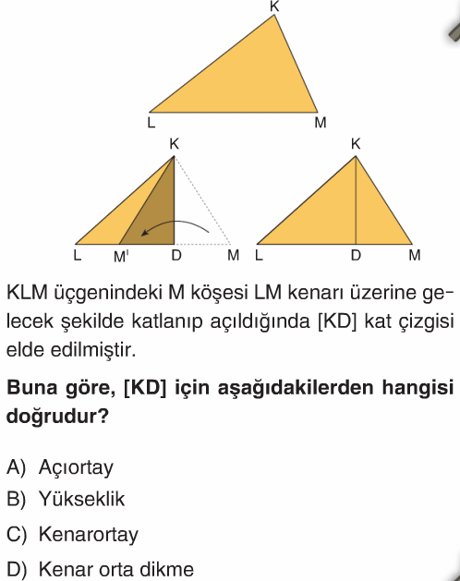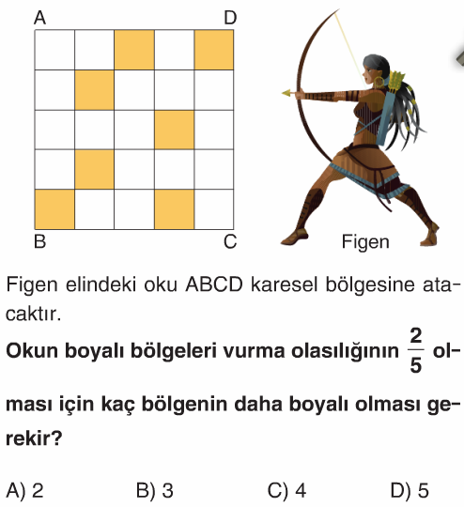

***18----------------------------------------***

