



***Adı: Türkçe Tarih***

***Soyadı: Çalışma Kağıdı ....../....../2018***

***10-------------------------------------***

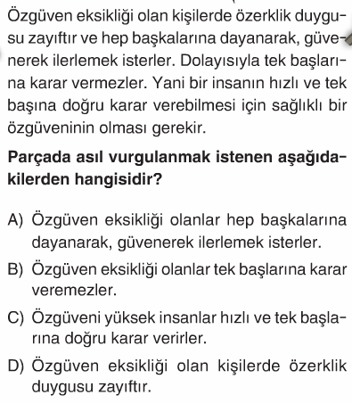

***11----------------------------------***

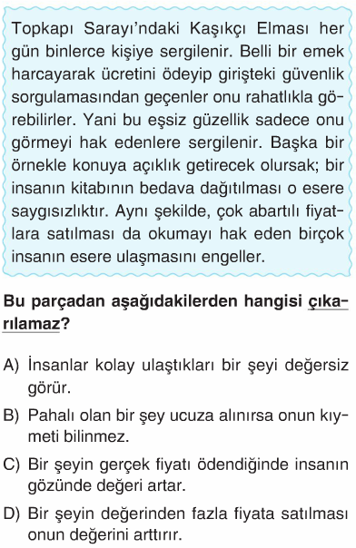

***5------------------------------------------***

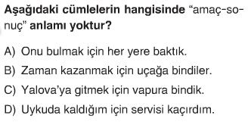

***6------------------------------------------***

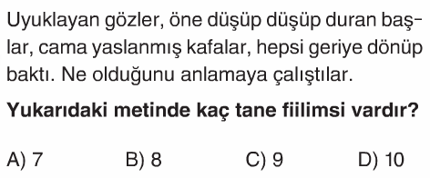

***7------------------------------------------***

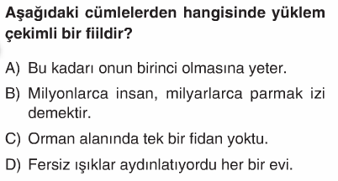

***8------------------------------------------***

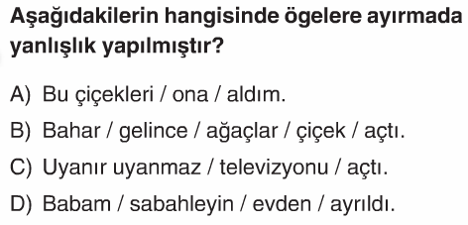

***9-----------------------------------------***

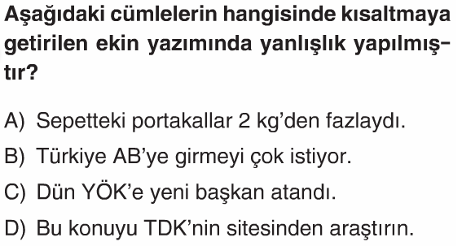

***---TÜRKÇE SORULARI---***

***1------------------------------------------***

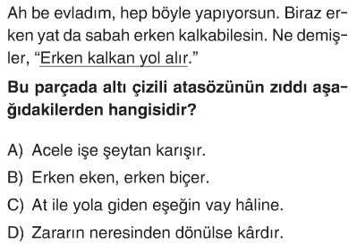

***2------------------------------------------***

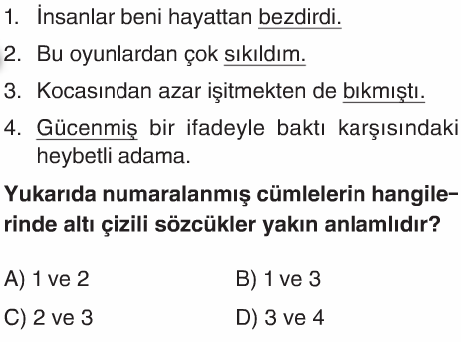

***3------------------------------------------***

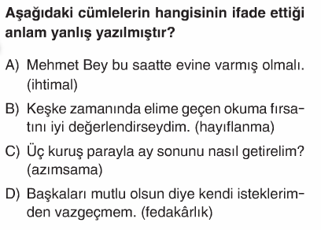

***4------------------------------------------***

***5------------------------------------------***

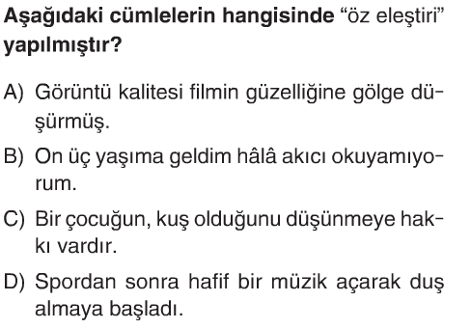

***19-------------------------------------***

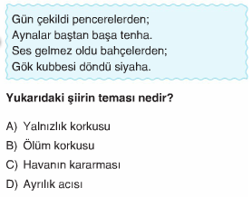

***20-------------------------------------***

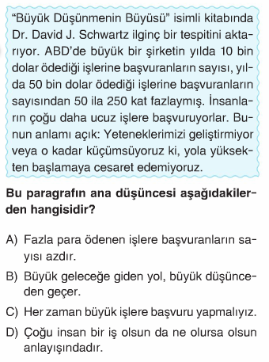

***ENES SERT***

***8/A SINIFI TÜRKÇE SORULARI***

***12------------------------------------------***

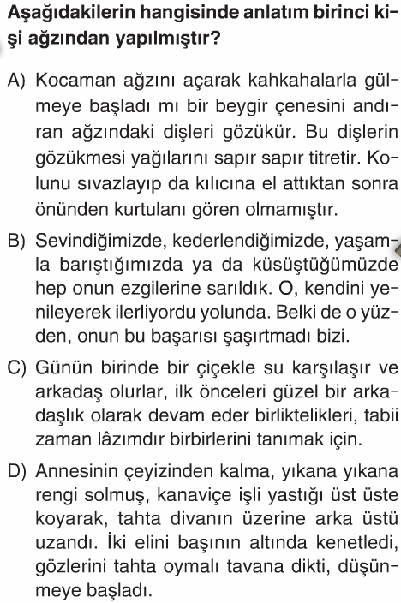

***13------------------------------------------***

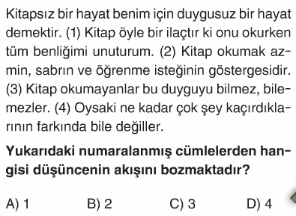

***14------------------------------------------***

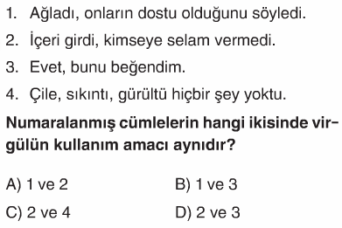

***15----------------------------------------***

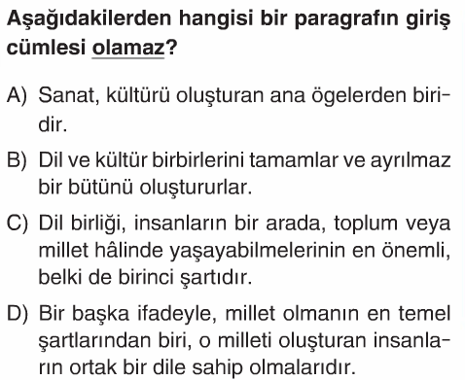

***16---------------------------------------***

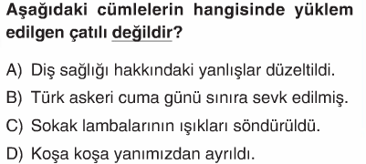

***17----------------------------------------***

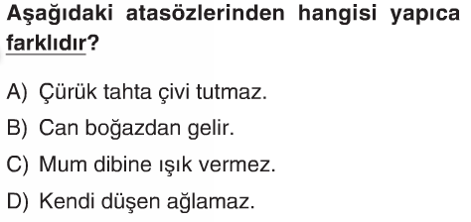

***18----------------------------------------***

